**SIMATS ENGINEERING**

**SAVEETHA INSTITUTE OF MEDICAL AND TECHNICAL SCIENCES CHENNAI-602105**

# CSA4385 – Internet Programming for Green App

**Capstone Project Report On:**

**“E – Library Management system.”**

Submitted

**By**

1. **Yamini - 192111343**

**V Srikari - 192211509**

**Faculty Name:**

**Venkatraman M**

**JUNE 2024**

### **Abstract:**

Online Library Management System is a system which maintains the information about the books present in the library, their authors, the members of library to whom books are issued, library staff and all. This is very difficult to organize manually. Maintenance of all this information manually is a very complex task.

Owing to the advancement of technology, organization of an Online Library becomes much simple. The Online Library Management has been designed to computerize and automate the operations performed over the information about the members, book issues and returns and all other operations. This computerization of library helps in many instances of its maintenances. It reduces the workload of management as most of the manual work done is reduced.

**INTRODUCTION**

This chapter gives an overview about the aim, objectives, background and operation environment of the system.

**PROJECT AIMS AND OBJECTIVES**

The project aims and objectives that will be achieved after completion of this project are discussed in this subchapter. The aims and objectives are as follows:

* + - Online book reading.
    - A search column to search availability of books.
    - Facility to download required book.
    - Video tutorial for students.
    - An Admin login page where admin can add books, videos or page sources

**SYSTEM ANALYSIS**

In this chapter, we will discuss and analyze about the developing process of Library Management System including software requirement specification (SRS) and comparison between existing and proposed system. The functional and non-functional requirements are included in SRS part to provide complete description and overview of system requirement before the developing process is carried out. Besides that, existing vs proposed provides a view of how the proposed system will be more efficient than the existing one.

**SOFTWARE REQUIREMENT SPECIFICATION:**

**GENERAL DESCRIPTION**

**PRODUCT DESCRIPTION:**

Library Management System is a computerized system which helps user(librarian) to manage the library daily activity in electronic format. It reduces the risk of paper work such as file lost, file damaged and time consuming.

It can help user to manage the transaction or record more effectively and time- saving.

**PROBLEM STATEMENT:**

The problem occurred before having computerized system includes:

* File lost

When computerized system is not implemented file is always lost because of human environment. Sometimes due to some human error there may be a loss of records.

* File damaged When a computerized system is not their file is always lost due to some accident like spilling of water by some member on file accidentally. Besides some natural disaster like floods or fires may also damage the files.
  + Difficult to search record

When there is no computerized system there is always a difficulty in searching of records if the records are large in number.

* + Space consuming

After the number of records become large the space for physical storage of file and records also increases if no computerized system is implemented.

* + Cost consuming

As there is no computerized system the to add each record paper will be needed which will increase the cost for the management of library.

#### **SYSTEM OBJECTIVES:**

* + Improvement in control and performance

The system is developed to cope up with the current issues and problems of library

. The system can add user, validate user and is also bug free.

* + Save cost

After computerized system is implemented less human force will be required to maintain the library thus reducing the overall cost.

* + Save time

Librarian is able to search record by using few clicks of mouse and few search keywords thus saving his valuable time.

* + Option of online Notice board

Librarian will be able to provide a detailed description of workshops going in the college as well as in nearby colleges

* + Lecture Notes

Teacher have a facility to upload lectures notes in a pdf file having size not more than 10mb.

#### **SYSTEM REQUIREMENTS:**

**NON FUNCTIONAL REQUIREMENTS**

The system should accurately perform member registration, member validation, report generation, book transaction and search

**USABILITY REQUIREMENT**

The system is designed for a user friendly environment so that student and staff of library can perform the various tasks easily and in an effective way.

**IMPLEMENTATION REQUIREMNTS**

In implementing whole system, it uses html in front end with php as server side scripting language which will be used for database connectivity and the backend i.e. the database part is developed using MySQL.

**DELIVERY REQUIREMENTS**

The whole system is expected to be delivered in six months of time with a weekly evaluation by the project guide.

**FUNCTIONAL REQUIREMENTS:**

**USER LOGIN:**

This feature used by the user to login into system. They are required to enter user id and password before they are allowed to enter the system. The user id and password will be verified and if invalid id is there user is allowed to not enter the system.

**Functional requirements**

-user id is provided when they register

-The system must only allow user with valid id and password to enter the system

-The system performs authorization process which decides what user level can access to.

-The user must be able to logout after they finished using system.

**REGISTER NEW USER**

This feature can be performed by all users to register new user to create account.

**Functional requirements**

-System must be able to verify information

-System must be able to delete information if information is wrong

**REGISTER NEW LOGIN**

This feature allows to add new books to the library

**Functional requirements**

-System must be able to verify information

-System must be able to enter number of copies into table.

- System must be able to not allow two books having same book id.

**SEARCH BOOKDESCRIPTION OF FEATURE**

This feature is found in book maintenance part. we can search book based on book id, book name, publication or by author name.

**SOFTWARE AND HARDWARE REQUIREMENTS:**

This section describes the software and hardware requirements of the system

**SOFTWARE REQUIREMENTS**

* + - * + Operating system- Windows 7 is used as the operating system as it is stable and supports more features and is more user friendly
        + Database MYSQL-MYSQL is used as database as it easy to maintain and retrieve records by simple queries which are in English language which are easy to understand and easy to write.
        + Development tools and Programming language- HTML is used to write the whole code and develop webpages with css, java script for styling work and php for sever side scripting.

#### **SOFTWARE TOOLS USED:**

The whole Project is divided in two parts the front end and the back end.

The front end is designed using of html, Php, css, Java script

#### **Library Table from Database**

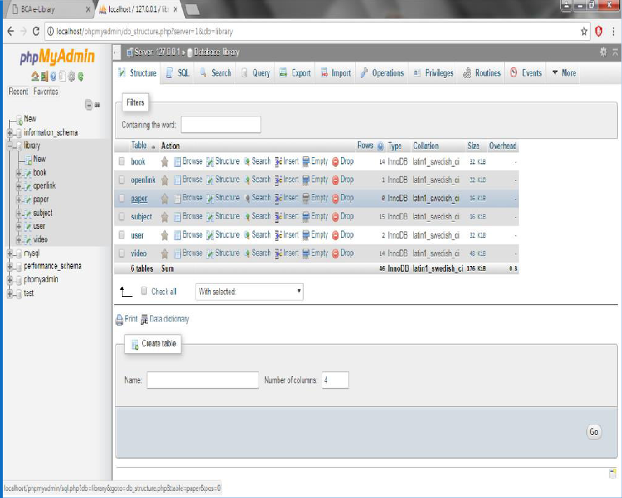

* + **Admin Table from Database**

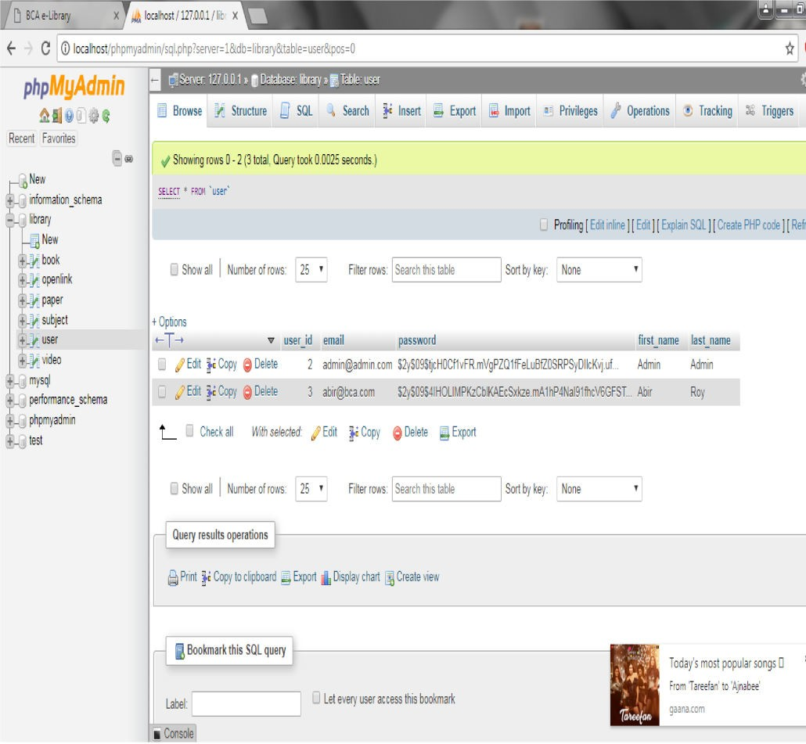

#### **Subjects Table from Database**

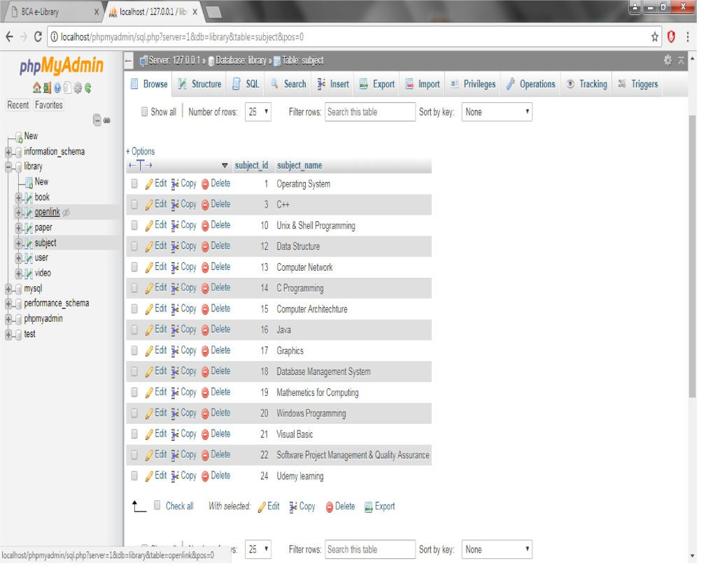

* **Books Table from Database Books Table from Database**

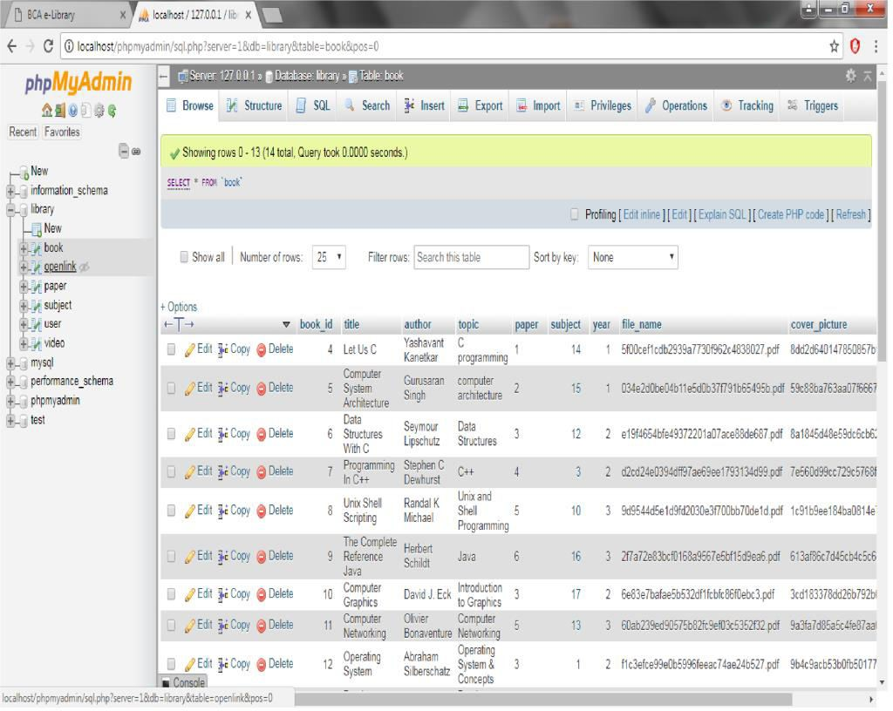

#### **Videos Table from Database**

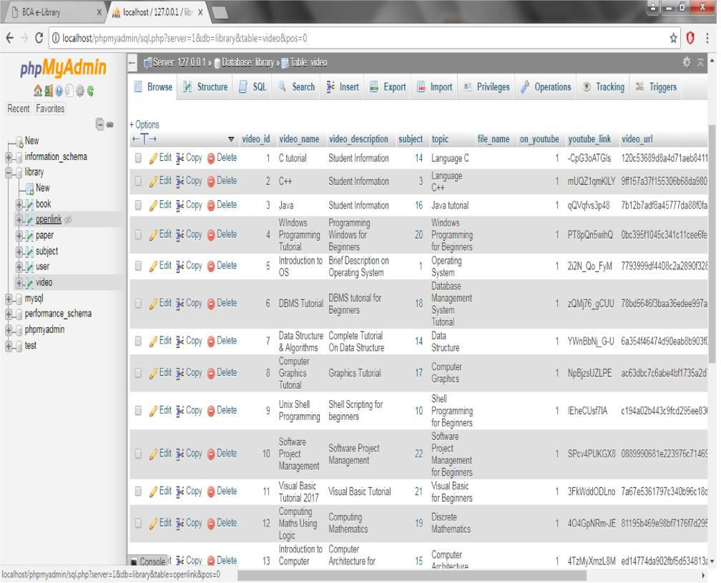

* + **Open link Table from Database**

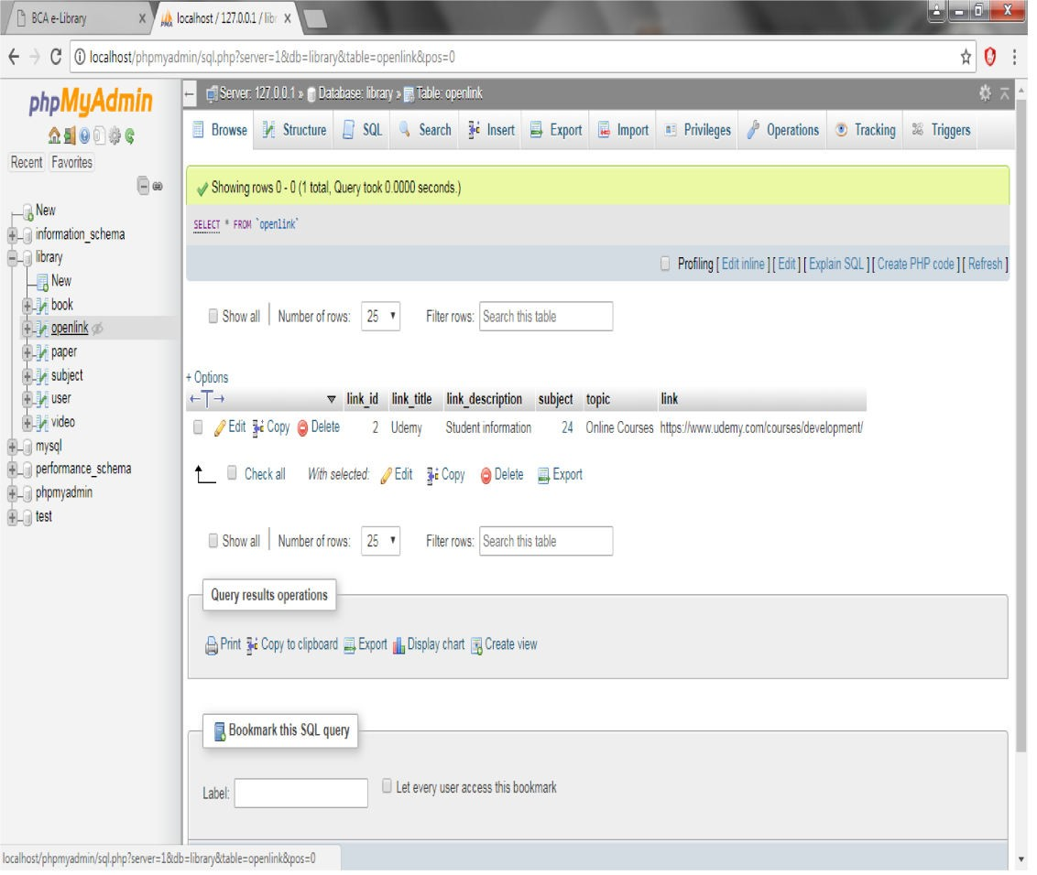

# CONCLUSION& FUTURE SCOPE

This website provides a computerized version of library management system which will benefit the students as well as the staff of the library.

It makes entire process online where student can search books, staff can generate reports and do book transactions. It also has a facility for student login where student can login and can see status of books issued as well request for book or give some suggestions.

It has a facility of teacher’s login where teachers can add lectures notes and also give necessary suggestion to library and also add info about workshops or events happening in our college or nearby college in the online notice board.

There is a future scope of this facility that many more features such as online lectures video tutorials can be added by teachers as well as online assignments submission facility, a feature of group chat where students can discuss various issues of engineering can be added to this project thus making it more interactive more user friendly and project which fulfills each users need in the best way possible.